**Drink And Delight**

**Class Diagrams**

1.Class Diagrm for Raw Material Stock

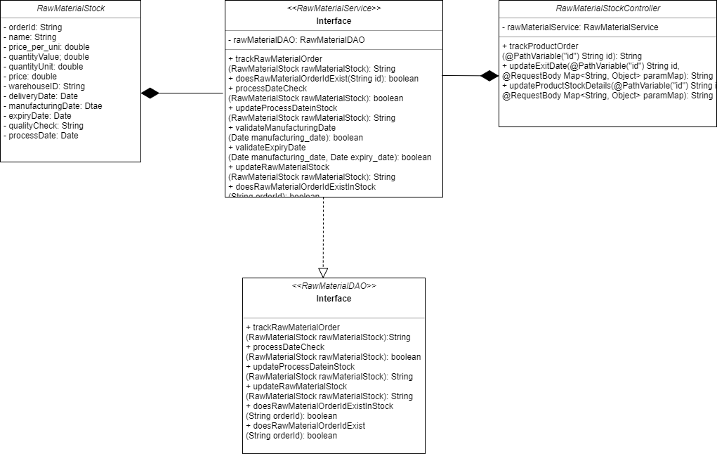

2.Class Diagram for Product Stock

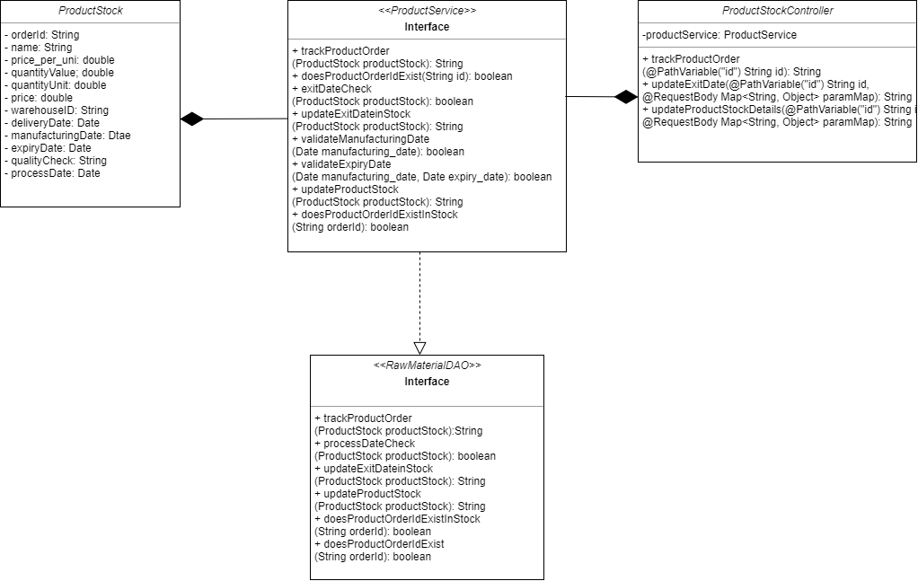

3.Class Diagram for Raw Material Order Management

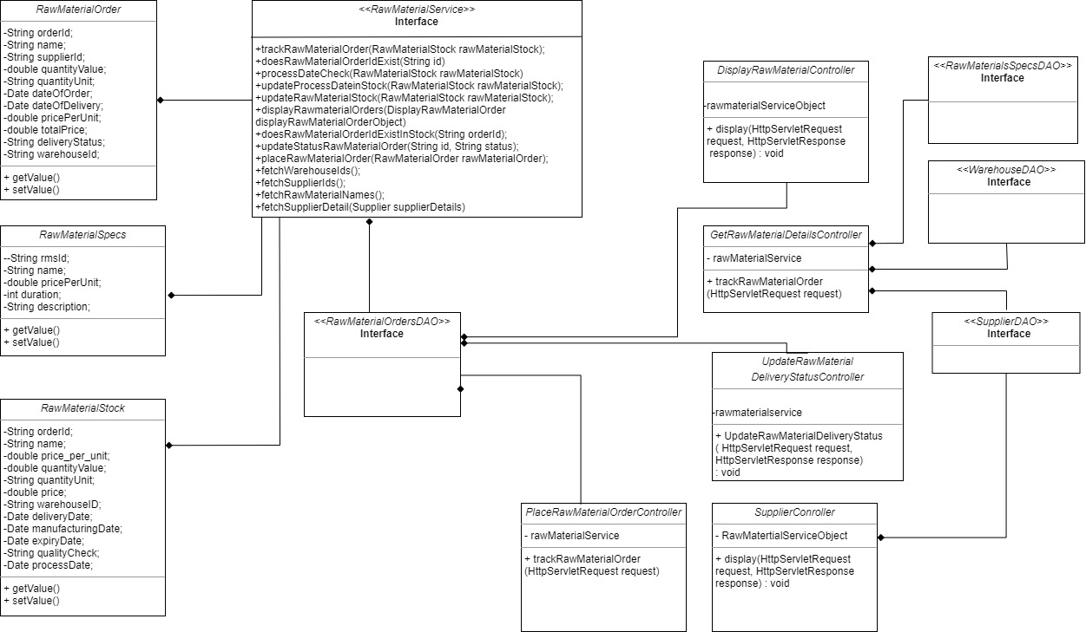

**Sequence Diagrms**

1.Sequence Diagram for Product Mangement System

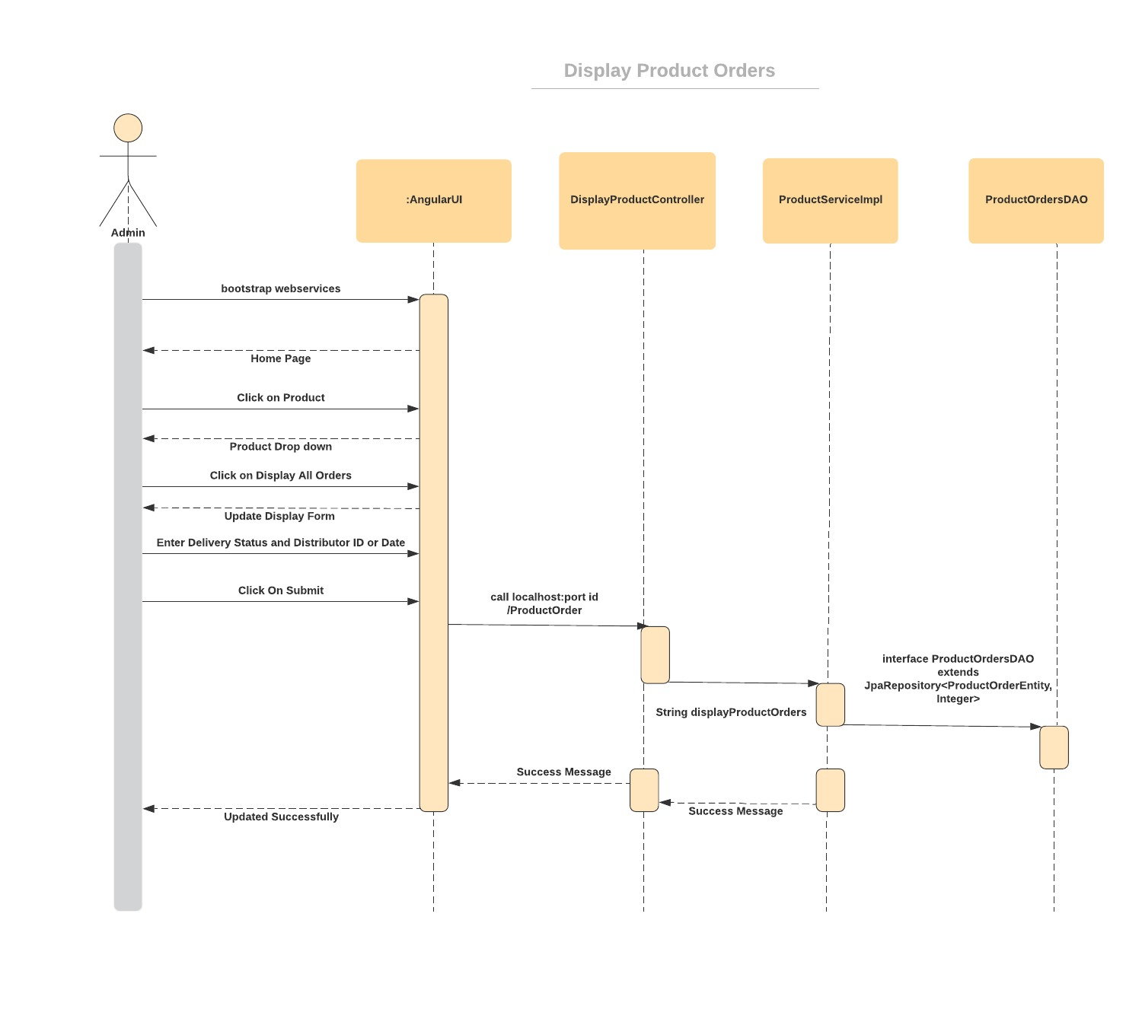

Display Distributer Details

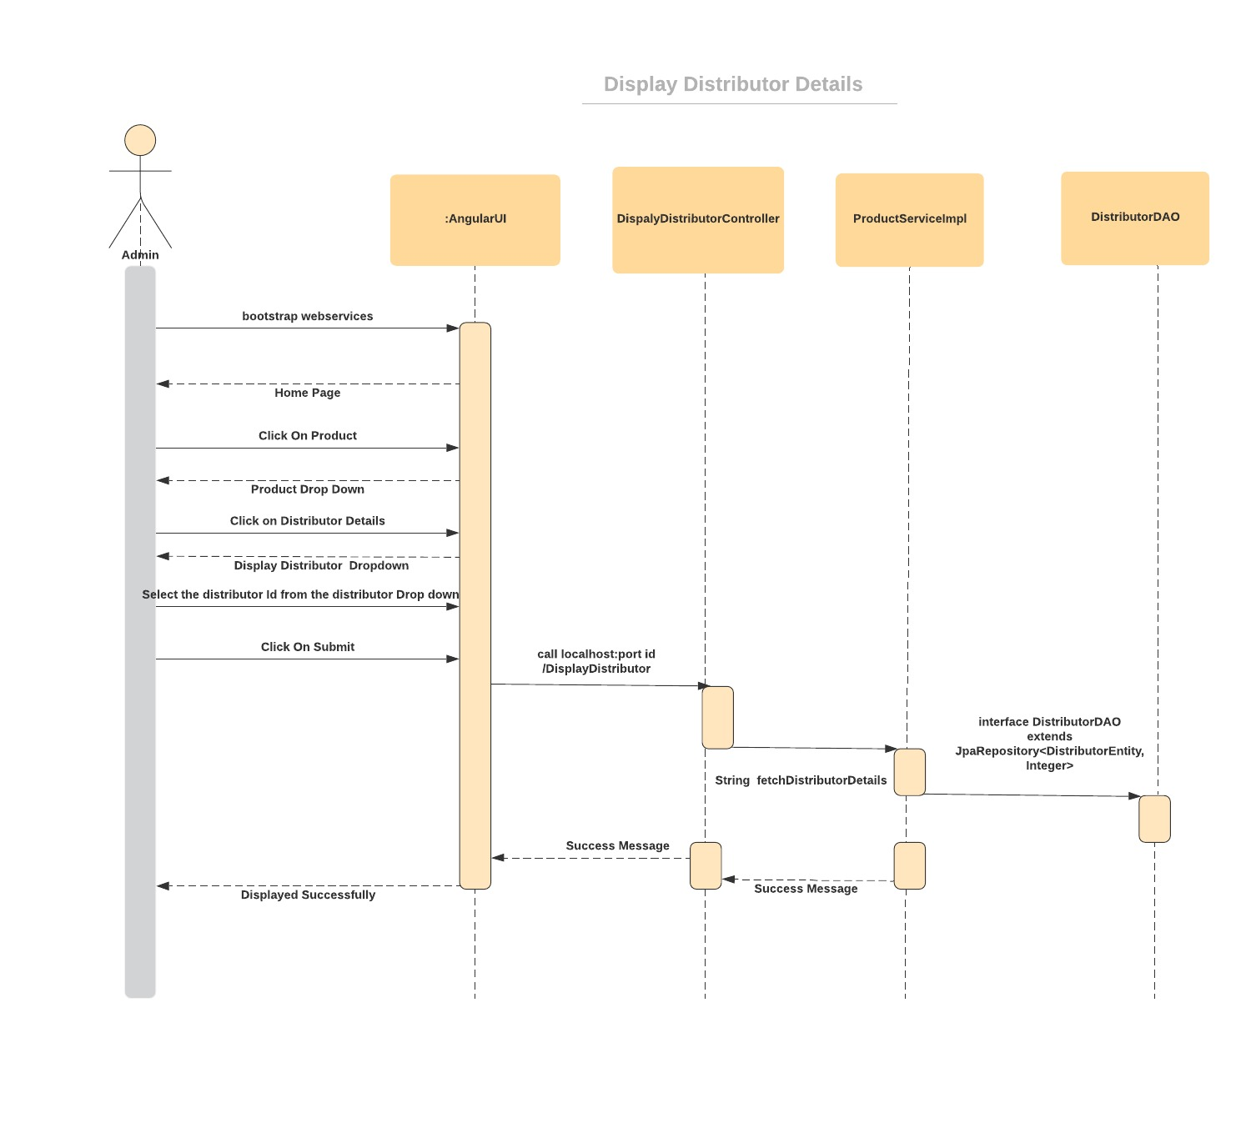

2.Sequence Diagram of Raw Material Management System

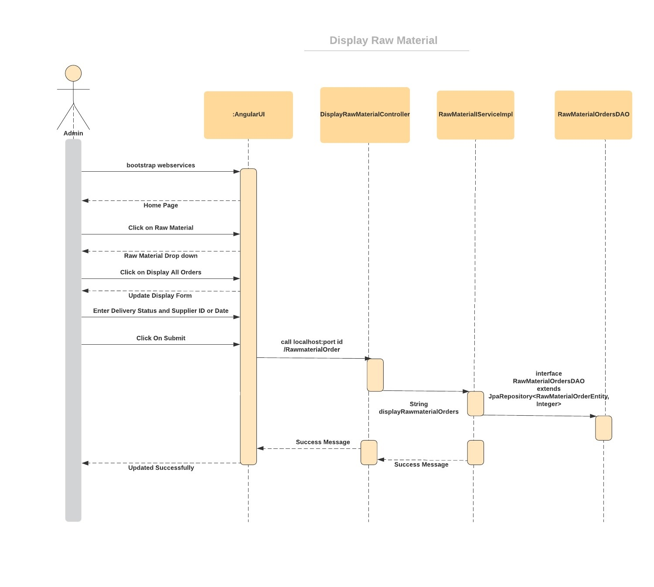

Display Supplier Details

